Supplementary Materials
This file and additional supplementary data can be found at:
http://www.bcgsc.ca/gc/bomge/coexpression/suppl_materials

Supplementary Results
Cancer sample analysis
Cancer samples were found to represent a substantial fraction in the cDNA (~29%), Affymetrix (~40% of the complete 889 samples) and SAGE (~61%) datasets. Cancer tissues are often characterized by changes in gene expression and thus could act as a confounding factor when trying to identify co-expressed genes. To investigate this issue the SAGE dataset was divided into cancer and normal subsets and consistency between these measured. The comparison of normal and cancer SAGE libraries resulted in a correlation of 0.324 for an MCE of 23 and 0.707 for an MCE of 80 (MCE of 100 could not be used because the normal tissue subset only contained 94 samples). These results are comparable to that seen for consistencies of SAGE when not taking cancer status into account (Suppl. Fig. 3). Thus, we cautiously concluded that the presence of cancer libraries was not seriously affecting the SAGE co-expression analysis and proceeded to subsequent analyses without removing the cancer libraries.

Ranked Match Analysis
The ranked match analysis shows that different expression platforms can identify the same co-expressed genes (Suppl. Fig. 5). It may be that for gene A, SAGE experiments identify its most similar gene (in terms of expression patterns) to be gene B with a Pearson correlation of 0.9. The cDNA microarray data might also identify gene B as the closest gene to A but with a Pearson value of 0.78. Thus, a comparison of Pearson ranks may be a more useful method for evaluating cross platform consistency than actual Pearson values. The Affymetrix/cDNA comparison found that 26.5% of genes have a co-expressed gene of Pearson rank 10 or better confirmed by both platforms compared to 18.9% for random data. Affymetrix versus SAGE agreed for 26.4% of genes compared to 18.9% for random, and cDNA versus SAGE for 21.8% compared to 18.8% for random. The high percentages of genes in agreement for random data are the result of our MCE criteria. Each gene pair must have at least 95, 28 or 23 MCE (for Affymetrix, cDNA and SAGE respectively). Some genes will have close to this number of experiments and thus realize the required MCE for only a few gene pair comparisons. Since we only consider gene pairs that are common in all three datasets, there will be some genes that only have a little more than 10 gene pairs. In these cases, a shared match within a rank of 10 for the two platforms will occur quite commonly by chance. Thus, it is the difference over random, rather than the actual percentage, that indicates a significant number of shared matches. In all three comparisons, the percentage of shared matches observed was significantly greater than that observed between randomized datasets (p<0.001, 1000 randomizations). We can conclude that the platform comparisons do identify more of the same co-expressed genes than expected by chance. However, in general the platforms show poor agreement.

Supplementary Methods
Data Filtering (SAGE)
Of the 5881 genes we mapped tags to and used in the analysis, 2374 (40%) had tags from the 1st position, 878 (15%) from the 2nd, 586 (10%) from the 3rd, 400 (7%) from the 4th, 335 (6%) from the 5th, and so on. In total, 40% were canonical tags, and 65% were from the lowest 3 positions. It is estimated that 30-50% of human genes are likely to use multiple different polyadenylation signals [1,2] and 38% of human genes generate more than one tag due to alternative splicing [3]. If these different transcript forms are not all represented in RefSeq or MGC, some of these would appear to be internal tags. Therefore, it is expected that some tags will not map to the canonical 3’-most position and we felt the best approach was to use the mapping that was closest.

In the event of discrepancy between Refseq and MGC, the former was taken as correct because a larger number of tags could be mapped with this resource (9568 vs 6295) and was thus perceived to be more complete. Only 297 tags with disagreements between Refseq and MGC are represented in the final gene set used in the analysis. Of these, we anticipate that some will be correct mappings, other incorrect, and others ambiguous (i.e. the tag does not uniquely represent a single gene). Thus, in less than 5% of the genes, there may be a bias towards lower correlation for comparisons involving the SAGE data. We believe this has a minimal effect on our overall results and does not alter our conclusions. It is likely that the data from each platform can be improved by altering mapping, normalization, etc. These improvements will likely increase the overall correlation. For example, a recent study showed that sequence-based (instead of annotation-based) matching between oligo and cDNA arrays significantly improved platform concordance [6,7]. The purpose of the current study was not to identify the best data processing methods for each platform. Instead, we attempted to choose the most standard or commonly used methods of identifying coexpressed genes and demonstrate that coexpression predicted by multiple platforms is more reliable. Future analyses in our lab that make use of coexpression will incorporate improved mapping methods (especially in the case of SAGE). Updated gene lists using our methods are provided on a separate website to include new sources of data, other species, and new mapping methods (http://www.bcgsc.ca/gc/bomge/coexpression/).

Cancer Sample Analysis
The proportion of cancer samples was determined from the literature for the cDNA dataset [4] and from GEO sample records for Affymetrix and SAGE. SAGE, having the highest percentage of cancer samples, was used for the analysis. The SAGE data set was manually divided into 94 normal and 148 cancer libraries based on sample descriptions from the GEO sample records. The consistency between these two subsets of the data was calculated as described above and compared to the other data sets.

Ranked Match Analysis
In addition to considering the actual Pearson correlation between each gene pair and comparing between platforms, the correlation rank was considered. This analysis identifies shared co-expressed genes, or matches, between platforms. For instance, a shared match would be illustrated by the following: Gene A’s 2nd most similar gene is gene B in the Affymetrix data. This is gene A’s 3rd most similar gene in the SAGE data. This example would count as one shared ‘match’ for a neighborhood of k = 3 for the Affymetrix versus SAGE comparison. A Perl script was written to determine each gene’s closest k neighbors from one dataset and compare to another dataset. Numbers of shared neighbors within each neighborhood size (k) were tallied and graphed. 1000 randomizations were conducted for each platform comparison to determine how often the level of agreement at each neighborhood would be observed by chance.

Supplementary Figures
Suppl. Figure 1. Venn Diagram outlining datasets used in analysis.
N indicates the number of experiments available for the platform. For Affymetrix, the number in brackets indicates the subset of experiments providing detection (PMA) calls. The number of genes represents only those genes that could be unambiguously mapped to a LocusLink ID.
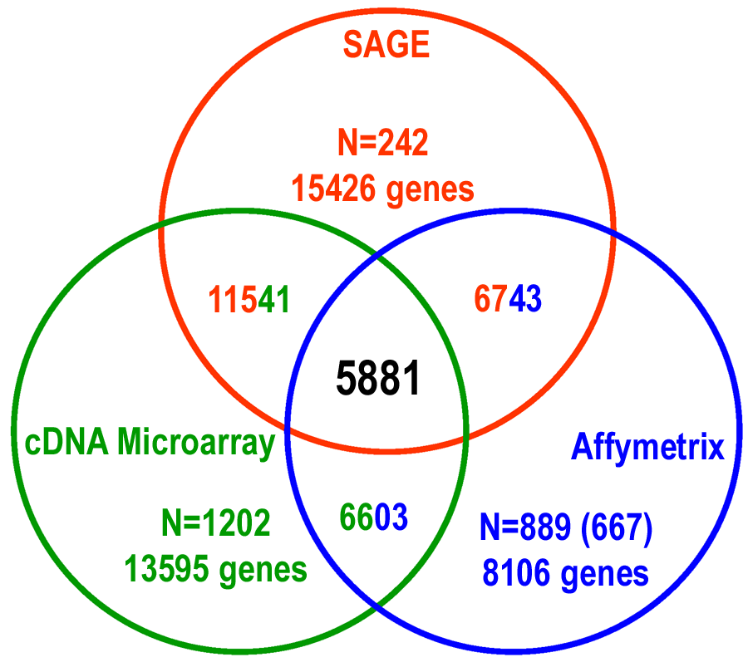

Suppl. Figure 2. Internal consistency analysis based on random division of experiments.
Analysis is identical to Figure 1, except division of libraries is random rather than by experiment, author, or tissue, resulting in much higher r_{c} values due to presence of replicates or very similar experiments. Data represent mean r_{c} value and gene pair number of 100 random divisions. Error bars indicate one standard deviation.
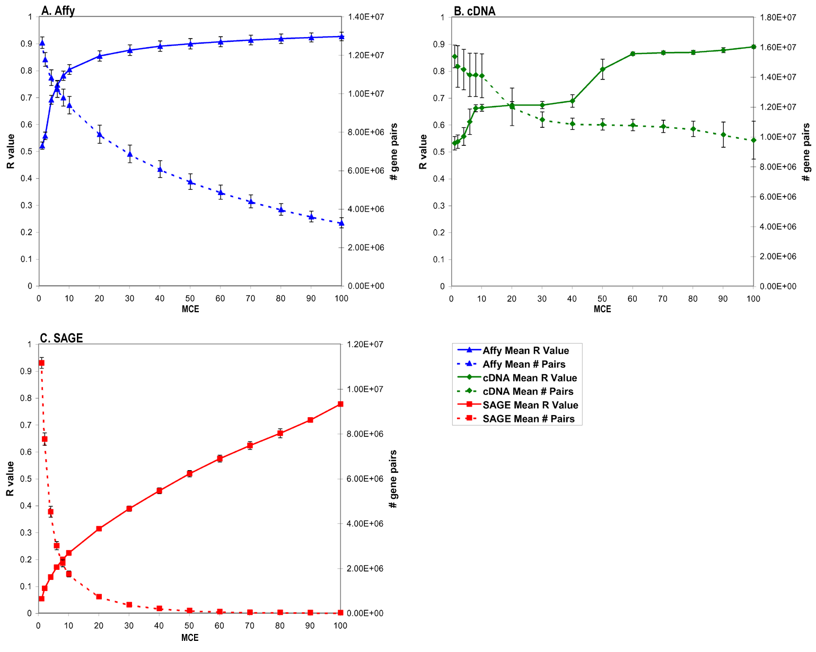
Suppl. Figure 3. SAGE cancer versus normal analysis.
Plots represent correlation of correlations for subsets of SAGE data. (A) Correlation between normal and cancer SAGE libraries, r_{c}=0.324 for 23 MCE; (B) Correlation between randomly divided subsets of SAGE data, r_{c}=0.267 for MCE of 23.
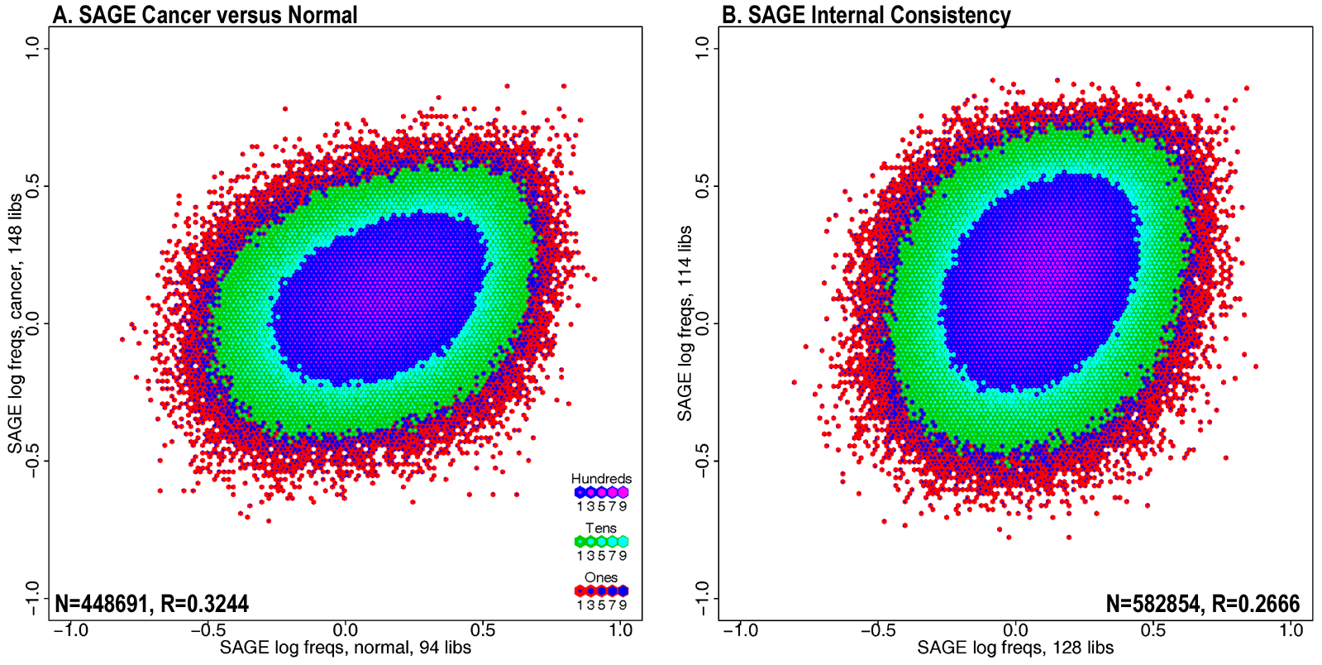
Suppl. Figure 4. Platform Comparisons.
Plots represent correlation of correlations (r_{c}) between each pairwise platform comparison. A. Affymetrix versus cDNA, r_{c}=0.102; B. Affymetrix versus SAGE, r_{c}=0.086; C. cDNA versus SAGE, r_{c}=0.041. 1,173,330 gene pairs are shown representing the intersection between Affymetrix, cDNA, and SAGE for which 95, 28, and 23 MCE were required respectively for each Pearson correlation calculation. Correlations observed in A-C were significant when compared to randomized data (p<0.001, 1000 randomizations). Small inset boxes show representative randomized data; D-E. Pearson correlation (r) frequency distributions for each platform. Notice that each displays a similar, approximately normal distribution with a slight skew towards positive correlations.
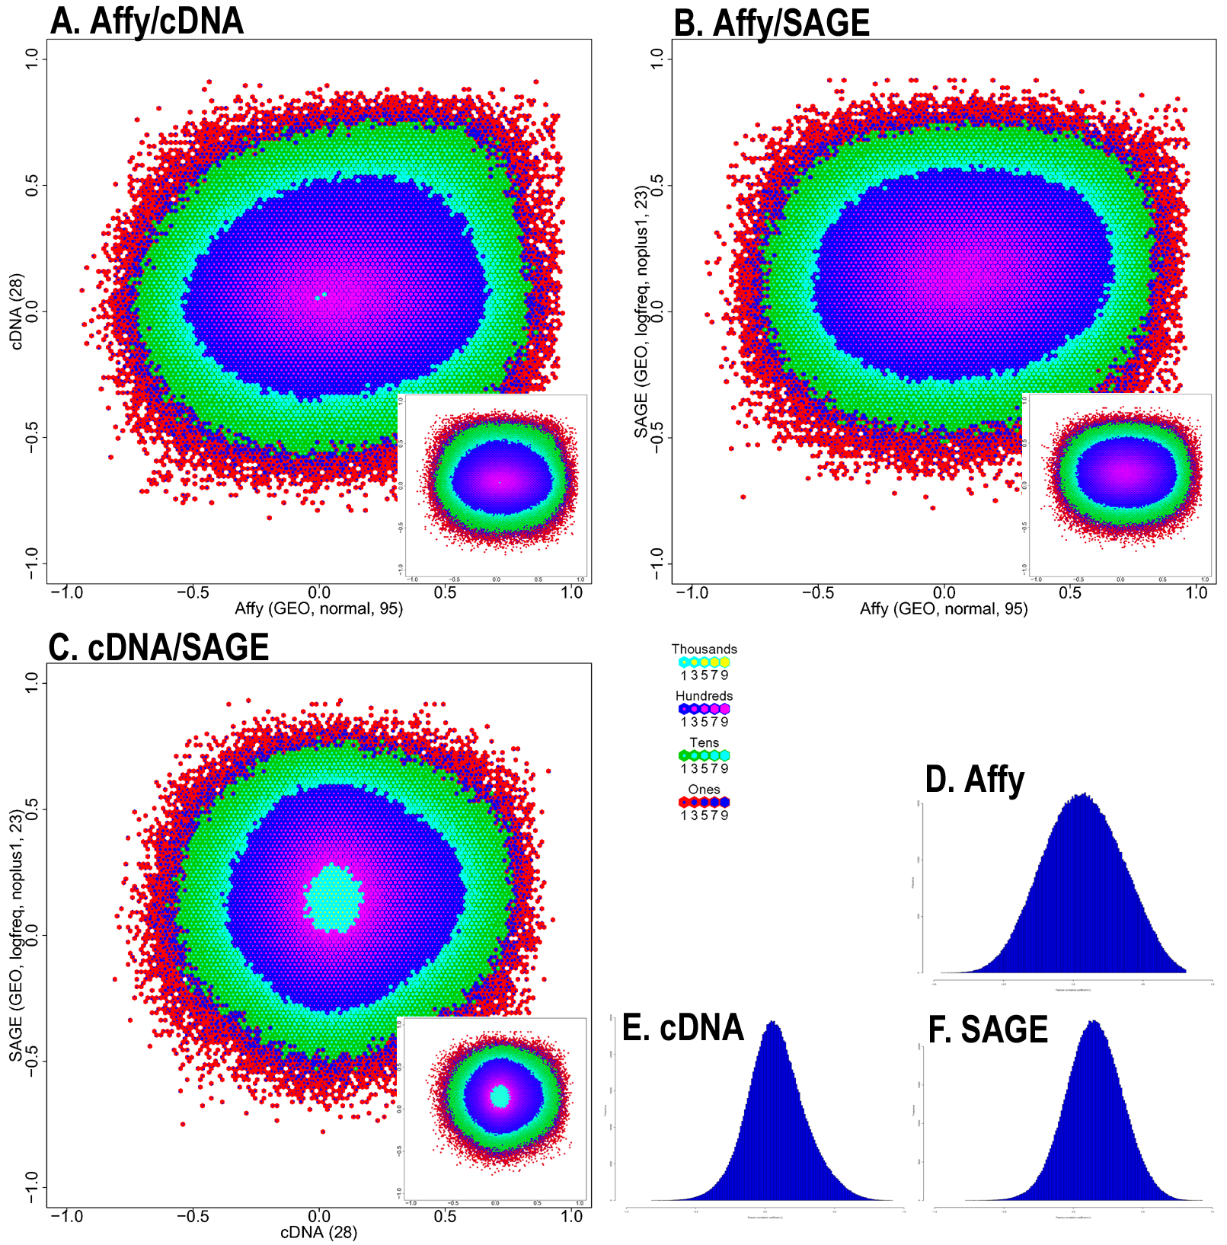
Suppl. Figure 5. Ranked Pearson Analysis.
Percentage of genes with a co-expressed gene identified by both platforms within a rank or neighborhood of k for each platform comparison. Random lines represent mean values from 1000 randomizations. Error bars indicate one standard deviation.
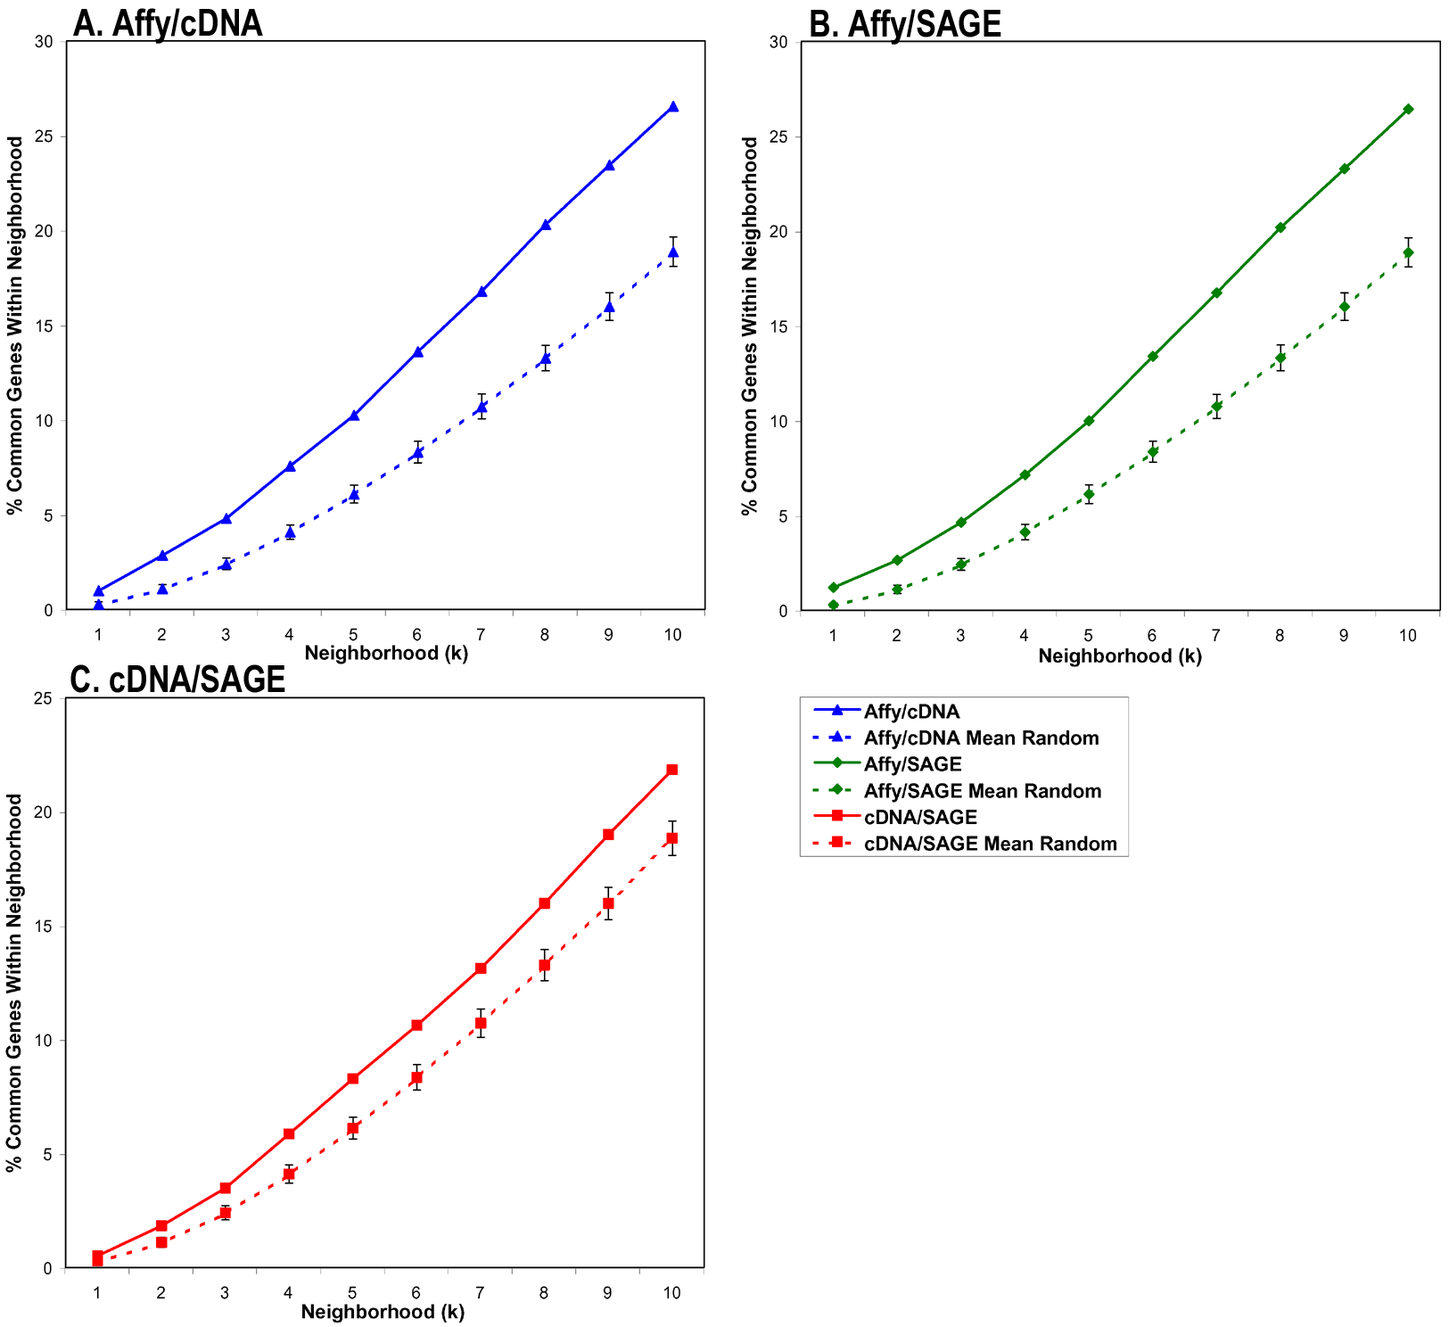
Suppl. Figure 6. Effect of correlation cutoff on r_{c}.
Platform comparisons (Suppl. Fig. 4) were repeated with subsets of gene pairs with correlations above cutoffs (0.1 increments). Only positive correlations were considered. Higher global concordance was observed for the Affymetrix/cDNA comparison at a Pearson cutoff (r-cutoff) of 0.65 and for the Affymetrix/SAGE comparison at r-cutoff of 0.6 and 0.7 (p<0.05). The cDNA/SAGE comparison did not show any increase that was significant. In any case, the steady trend of increasing r_{c} with more stringent r-cutoff was not observed as reported elsewhere [5]. Asterisks indicate increased r_{c} values which were also found to be significant (p<0.05).
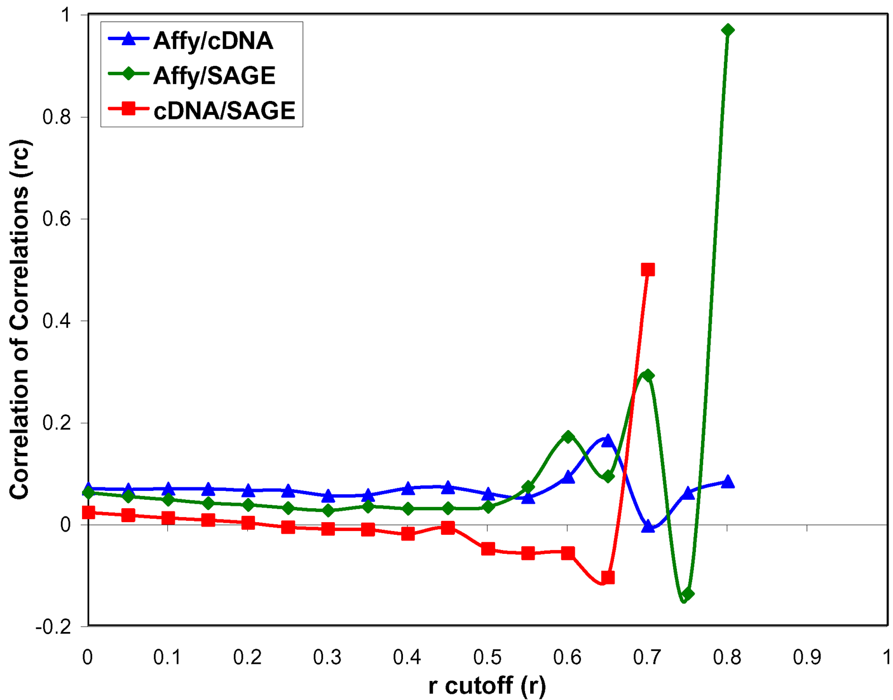
Suppl. Figure 7. GO Analysis.
Gene pairs for which both genes were annotated with Gene Ontology Biological Process terms were evaluated to determine the percentage of pairs within a neighborhood of k that are annotated with the same GO term. As the GO annotation is hierarchical, only the most specific GO terms for each gene were considered. Comparison of these percentages to results produced from randomizing gene pair correlations indicate that gene pairs found to be correlated by any platform are more likely to share the same function than randomly chosen gene pairs (p<0.001, 1000 randomizations). Affymetrix appears to predict the most biologically relevant gene pair correlations.
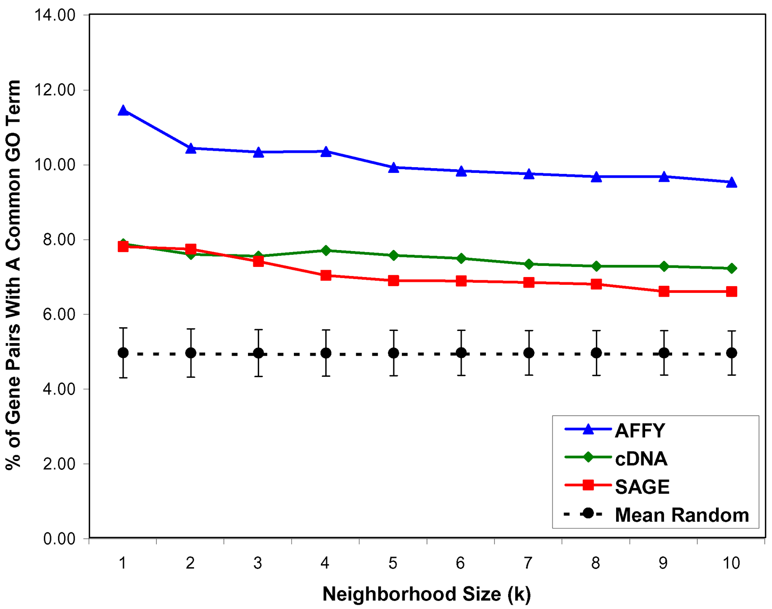
Suppl. Figure 8. Expanded Go Analysis including hierarchical relationships.
Analysis performed as for Suppl. Figure 7, but in addition to considering only most specific GO term annotations (A), the percentage of gene pairs sharing parent terms (B) or parent and grandparent terms (C) were also determined. As higher levels in the GO hierarchical tree (parent and grandparent terms) are considered, there is a higher chance that randomly chosen gene pairs will share GO terms, resulting in less difference between random and actual data.

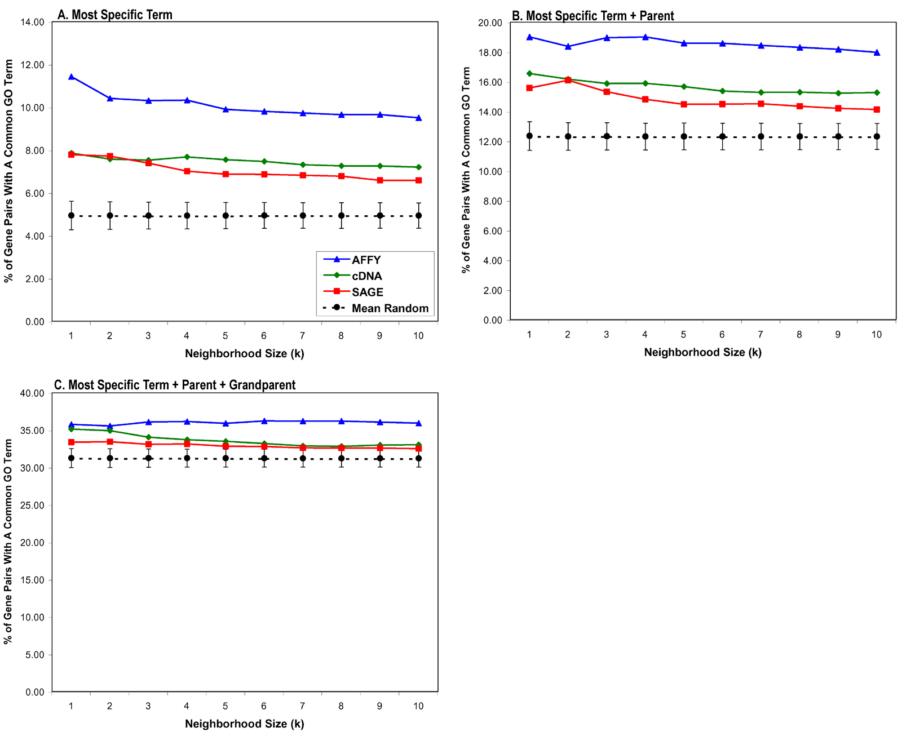
Suppl. Figure 9. GO categories for gene pairs confirmed by multiple datasets. The chart shows GO terms of gene pairs with an average Pearson correlation of r>0.6 for any two of three platform datasets (Affymetrix, cDNA microarray, SAGE). The legend only shows the 32 categories with more than one gene pair. However, another 20 categories are represented on the chart and are summarized in Suppl. Table 1.
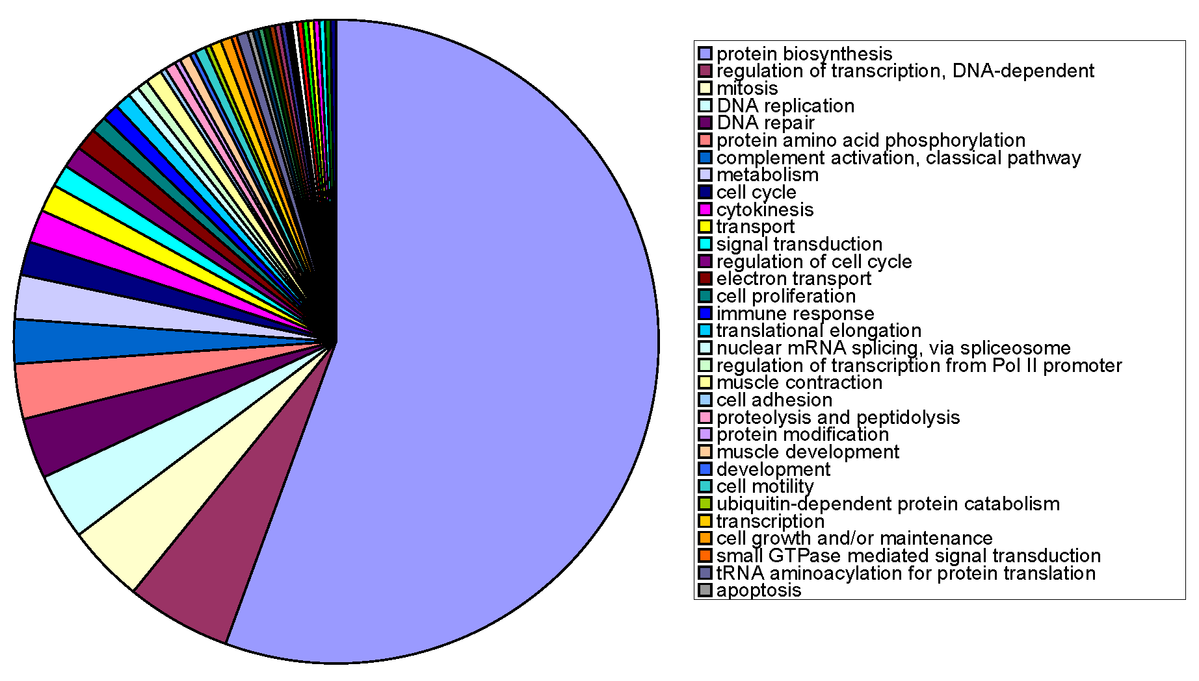
Suppl. Table 1.
Gene Pairs | Percent | Common Term | Go Term
257 | 55.508 | GO:0006412 | protein biosynthesis
25 | 5.3996 | GO:0006355 | regulation of transcription, DNA-dependent
18 | 3.8877 | GO:0007067 | mitosis
15 | 3.2397 | GO:0006260 | DNA replication
14 | 3.0238 | GO:0006281 | DNA repair
13 | 2.8078 | GO:0006468 | protein amino acid phosphorylation
11 | 2.3758 | GO:0006958 | complement activation, classical pathway
10 | 2.1598 | GO:0008152 | metabolism
8 | 1.7279 | GO:0007049 | cell cycle
7 | 1.5119 | GO:0000910 | cytokinesis
6 | 1.2959 | GO:0006810 | transport
6 | 1.2959 | GO:0007165 | signal transduction
5 | 1.0799 | GO:0000074 | regulation of cell cycle
5 | 1.0799 | GO:0006118 | electron transport
4 | 0.8639 | GO:0008283 | cell proliferation
4 | 0.8639 | GO:0006955 | immune response
3 | 0.6479 | GO:0006414 | translational elongation
3 | 0.6479 | GO:0000398 | nuclear mRNA splicing, via spliceosome
3 | 0.6479 | GO:0006357 | regulation of transcription from Pol II promoter
3 | 0.6479 | GO:0006936 | muscle contraction
2 | 0.432 | GO:0007155 | cell adhesion
2 | 0.432 | GO:0006508 | proteolysis and peptidolysis
2 | 0.432 | GO:0006464 | protein modification
2 | 0.432 | GO:0007517 | muscle development
2 | 0.432 | GO:0007275 | development
2 | 0.432 | GO:0006928 | cell motility
2 | 0.432 | GO:0006511 | ubiquitin-dependent protein catabolism
2 | 0.432 | GO:0006350 | transcription
2 | 0.432 | GO:0008151 | cell growth and/or maintenance
2 | 0.432 | GO:0007264 | small GTPase mediated signal transduction
2 | 0.432 | GO:0006418 | tRNA aminoacylation for protein translation
2 | 0.432 | GO:0006915 | apoptosis
1 | 0.216 | GO:0015031 | protein transport
1 | 0.216 | GO:0006461 | protein complex assembly
1 | 0.216 | GO:0008380 | RNA splicing
1 | 0.216 | GO:0006364 | rRNA processing
1 | 0.216 | GO:0006366 | transcription from Pol II promoter
1 | 0.216 | GO:0007242 | intracellular signaling cascade
1 | 0.216 | GO:0006091 | energy pathways
1 | 0.216 | GO:0006635 | fatty acid beta-oxidation
1 | 0.216 | GO:0006177 | GMP biosynthesis
1 | 0.216 | GO:0006096 | glycolysis
1 | 0.216 | GO:0006259 | DNA metabolism
1 | 0.216 | GO:0007186 | G-protein coupled receptor protein signaling pathway
1 | 0.216 | GO:0007267 | cell-cell signaling
1 | 0.216 | GO:0006098 | pentose-phosphate shunt
1 | 0.216 | GO:0006917 | induction of apoptosis
1 | 0.216 | GO:0016575 | histone deacetylation
1 | 0.216 | GO:0006954 | inflammatory response
1 | 0.216 | GO:0045786 | negative regulation of cell cycle
1 | 0.216 | GO:0009966 | regulation of signal transduction
463 | 100 | 52

References

[1] E. Beaudoing, S. Freier, J.R. Wyatt, J.M. Claverie, D. Gautheret, Patterns of variant polyadenylation signal usage in human genes, Genome Res 10 (2000) 1001-10.
[2] C. Iseli, et al., Long-range heterogeneity at the 3' ends of human mRNAs, Genome Res 12 (2002) 1068-74.
[3] P. Unneberg, A. Wennborg, M. Larsson, Transcript identification by analysis of short sequence tags--influence of tag length, restriction site and transcript database, Nucleic Acids Res 31 (2003) 2217-26.
[4] J.M. Stuart, E. Segal, D. Koller, S.K. Kim, A gene-coexpression network for global discovery of conserved genetic modules, Science 302 (2003) 249-55.
[5] J.K. Lee, et al., Comparing cDNA and oligonucleotide array data: concordance of gene expression across platforms for the NCI-60 cancer cells, Genome Biol 4 (2003) R82.

